A

PROJECT REPORT

ON

**STEGPIXEL**

Towards partial fulfillment of the requirement in

**5th Semester BCA (2019-2020)**

**Submitted By:-**

**SURAJ SHUKLA(170510101072)**

**BAGENDA JUNIOR BAZIL(170510101094)**

**Submitted To:-**



**Parul Institute Of Computer Application,**

**Parul University.**

Under The Guidance of

*Miss. Anjali Mahavar,*

Assistant Professor

**ACKNOWLEDGEMENT**

Behind any major work undertaken by an individual there lies the contribution of the people who helped him to cross all the hurdles to achieve his goal.

It gives me the immense pleasure to express my sense of sincere gratitude towards my respected guide **Miss.** **Anjali Mahavar**, (Assistant Prof.) for her persistent, outstanding, invaluable co-operation and guidance.

I also express my deep sense of regards and thanks to **Miss. Hina Chokshi** , (**Head Of Department ,PICA**). I feel very privileged to have had their precious advices, guidance and leadership.

I respect and thank **Dr. Priya Swaminarayan, Dean ,FITCS** for providing us an opportunity to do the project work in BCA and giving all the support and guidance,which made us complete the project duly.We are extremely thankful to Ma’am for providing her support and guidance .

Last but not the least, my humble thanks to the Almighty God.

|  |  |  |
| --- | --- | --- |
|  |  | **Suraj Shukla** |
|  |  | **170510101072** |
| **Place: Vadodara** |  | **Junior Bazil** |
| **Date: 11/10/2019** |  | **170510101094** |

**ABSTRACT**

Steganography is technique and art of hiding a secret message in carrier file so that the existence of the secret messages cannot be known. As the rival method of detecting the presence of embedded data in media is called steganalysis. If anyone knew the existence of the secret message with its carrier file then steganography is failed. So, our project provides the security that anyone can send their private message and only receiver can read those messages.

**LIST OF TABLES**

|  |  |  |
| --- | --- | --- |
| Table No | Table Description | Page No |
| Table 3.1 | Before apply LSB | 3 |
| Table 3.2 | After apply LSB | 3 |
|  |  |  |

**LIST OF FIGURE**

Figure 1 : Time Line Chart 6

Figure 2: Use Case Diagram 9

Figure 3 : Class Diagram 10

Figure 4: Sequence Diagram 11

Figure 5: Activity Diagram 12

Figure 6: Context Diagram 13

Figure 7: GUI 14

Figure 8: Encryption tab 14

Figure 9: Selecting cover file 15

Figure 10: Decrypt tab 16

Figure 10: Selecting output encryption 16

Figure 11 : Encryption with password 17

Figure 13 : Decryption with password 18

Figure 14 : Mail Sender 19

INDEX

ACKNOWLEDGEMENT I

ABSTRACT II

LIST OF TABLES III

LIST OF FIGURE IV

INDEX V

1. INTRODUCTION TO PROJECT 1

1.1 Overview 1

1.2 Steganography 2

1.2.1 Advantages of the Steganography: 2

1.2.2 Disadvantages of the Steganography: 2

1.3 Research Methodology 3

2. FEASIBILITY STUDY 4

2.1 Need for Feasibility Study 4

2.2 Types Of Feasibility Study 5

2.3 Feasibility Study for My System 5

3. SYSTEM REQUIREMENT SPECIFICATION 6

3.1 Time line chart 6

3.2 Modules Of The System 7

3.3 Users 7

3.4 Description Of Modules Of The System 7

3.5 Description Of Users 8

3.6 Hardware And Software Requirements 8

3.6.1 Software requirement: 8

3.6.2 Hardware requirement: 8

4. SYSTEM DESIGN 9

4.1. General Use Case Diagram 9

4.2 Class diagram 10

4.3 Sequence Diagram 11

4.4 Activity Diagram 12

4.5 Data Flow Diagram 13

5. IMPLEMENTATION 14

5.1 Encryption 14

5.1.2 Selecting cover file 15

5.2 Decryption 16

5.2.2 Selecting output encrypting file 16

5.3 Encrypt with password 17

5.4 Decryption with password 18

5.5 Mail Sender 19

6. LIMITATIONS & FUTURE ENHANCEMENT 20

7. REFERENCES & BIBLIOGRAPHY 21

1. **INTRODUCTION TO PROJECT**

**1.1 Overview**

One of the reasons that intruders can be successful is the most of the information they acquire from a system is in a form that they can read and comprehend. Intruders may reveal the information to others, modify it to misrepresent an individual or organization, or use it to launch an attack. One solution to this problem is, through the use of steganography. Steganography is a technique of hiding information in digital media. In contrast to cryptography, it is not to keep others from knowing the hidden information but it is to keep others from thinking that the information even exists.

Steganography become more important as more people join the cyberspace revolution. Steganography is the art of concealing information in ways that prevents the detection of hidden messages. Steganography include an array of secret communication methods that hide the message from being seen or discovered.

The growing possibilities of modern communications need the special means of security especially on computer network. The network security is becoming more important as the number of data being exchanged on the internet increases. Therefore, the confidentiality and data integrity are requiring to protect against unauthorized access and use. This has resulted in an explosive growth of the field of information hiding.

Information hiding is an emerging research area, which encompasses applications such as copyright protection for digital media, watermarking, fingerprinting, and steganography.

In watermarking applications, the message contains information such as owner identification and a digital time stamp, which usually applied for copyright protection.

Fingerprint, the owner of the data set embeds a serial number that uniquely identifies the user of the data set. This adds to copyright information to makes it possible to trace any unauthorized use of the data set back to the user.

Steganography hide the secrete message within the host data set and presence imperceptible and is to be reliably communicated to a receiver. The host data set is purposely corrupted, but in a covert way, designed to be invisible to an information analysis.

**1.2 Steganography**

Steganography is the practice of hiding private or sensitive information within something that appears to be nothing out to the usual. Steganography is often confused with cryptology because the two are similar in the way that they both are used to protect important information. The difference between two is that steganography involves hiding information so it appears that no information is hidden at all. If a person or persons views the object that the information is hidden inside of he or she will have no idea that there is any hidden information, therefore the person will not attempt to decrypt the information.

What steganography essentially does is exploit human perception, human senses are not trained to look for files that have information inside of them, although this software is available that can do what is called Steganography. The most common use of steganography is to hide a file inside another file.

**1.2.1 Advantages of the Steganography:**

The advantages of the steganography are as below:

1. The steganography is for protecting the data, such as in the field of media where the copywriting ensures the authentication.
2. The steganography can be used by the intelligence agencies for transmitting their secret information.

**1.2.2 Disadvantages of the Steganography:**

The disadvantages of the steganography are as follows:

1. By using the steganography mechanism many terrorists and have anti-humanist activities have occurred.

**1.3 Research Methodology**

LSB ALGORITHM LSB algorithm is very simple and most widely used in steganography technique. This technique is used to hide text, image, audio as well as video . As the name, LSB says, only least significant bits are used to hide data. For an image with a pixel depth of 8 bits, any changes in two or three least significant bits do not affect much. In this technique before hiding data, each character of a secret message is converted to 8-bit binary sequence. These eight bits are replaced with eight least significant bits of the cover image pixel.

RGB image has three different channels: red, green and blue and each pixel is represented using 24 bits (8 bits for each channel). The information is hidden in all three channels using three bits in red, three bits in green and two bits in blue. The order of hiding the information can be any sequence. Simple example with a sequence of hiding RGBBGRRG (i.e. MSB of data is hidden in the red channel, next lower bit in the green channel, and so on) shown below.

Let the original value of an image pixel be: Red-187, Green- 233, and Blue-52.

|  |  |  |  |
| --- | --- | --- | --- |
| Channel | Red | Green | Blue |
| Bin Val | 10111011 | 11101001 | 00110100 |
| Dec val | 187 | 233 | 52 |

Table 3.2 : Before apply LSB

If the hiding sequence is 01011101 then after hiding data value of image pixel become:

|  |  |  |  |
| --- | --- | --- | --- |
| Channel | Red | Green | Blue |
| Bin Val | 10111010 | 11101111 | 00110110 |
| Dec val | 186 | 239 | 54 |

Table 3.2. After apply LSB

Above example clearly indicates the changes in pixel values. Since the changes are very small, human eye cannot identify these minute changes in pixel colour. At the decoding end bits are accessed from each pixel in the order same as they hide.

**2. FEASIBILITY STUDY**

A project feasibility study is a comprehensive report that examines in detail the five frames of analysis of a given project. It also takes into consideration its risks and its constraints (calendar, costs, and norms of quality). The goal is to determine whether the project should go ahead, be redesigned, or else abandoned altogether.

The five frames of analysis are: The frame of definition; the frame of contextual risks; the frame of potentiality; the parametric frame; the frame of dominant and contingency strategies.

The four P’s are traditionally defined as Plan, Processes, People, and Power. The risks are considered to be external to the project (e.g., weather conditions) and are divided in eight categories: (Plan) financial and organizational (e.g., government structure for a private project); (Processes) environmental and technological; (People) marketing and sociocultural; and (Power) legal and political. POVs are Points of Vulnerability: they differ from risks in the sense that they are internal to the project and can be controlled or else eliminated.

The constraints are the standard constraints of calendar, costs and norms of quality that can each be objectively determined and measured along the entire project lifecycle. Depending on projects, portions of the study may suffice to produce a feasibility study; smaller projects, for example, may not require an exhaustive environmental assessment.

**2.1 Need for Feasibility Study**

A feasibility study aims to objectively and rationally uncover the strengths and weaknesses of an existing business or proposed venture, opportunities and threats present in the [natural environment](https://en.wikipedia.org/wiki/Natural_environment" \o "Natural environment), the [resources](https://en.wikipedia.org/wiki/Resources" \o "Resources) required to carry through, and ultimately the prospects for success. In its simplest terms, the two criteria to judge feasibility are [cost](https://en.wikipedia.org/wiki/Cost" \o "Cost) required and [value](https://en.wikipedia.org/wiki/Value_(economics)" \o "Value (economics)) to be attained.

A well-designed feasibility study should provide a historical background of the business or project, a description of the [product](https://en.wikipedia.org/wiki/Product_(business)" \o "Product (business)) or [service](https://en.wikipedia.org/wiki/Service_(economics)" \o "Service (economics)), accounting statements, details of the [operations](https://en.wikipedia.org/wiki/Business_operations" \o "Business operations) and [management](https://en.wikipedia.org/wiki/Management" \o "Management), [marketing research](https://en.wikipedia.org/wiki/Marketing_research" \o "Marketing research) and policies, financial data, legal requirements and tax obligations.Generally, feasibility studies precede technical development and [project](https://en.wikipedia.org/wiki/Project" \o "Project) implementation.

A feasibility study evaluates the project's potential for success; therefore, perceived objectivity is an important factor in the credibility of the study for potential investors and lending institutions. It must therefore be conducted with an objective, unbiased approach to provide information upon which decisions can be based.

**2.2 Types Of Feasibility Study**

* Technical feasibility
* Legal Feasibility
* Resource Feasibility
* Financial Feasibility

**2.3 Feasibility Study for My System**

* **Technical feasibility**

- Method of production

- Production technique

- Project requirements

- Project location

* **Legal Feasibility**

-Approved by Government

-Harmless for society

**3. SYSTEM REQUIREMENT SPECIFICATION**

A software requirements specification (SRS) is a description of a [software system](https://en.wikipedia.org/wiki/Software_system" \o "Software system) to be [developed](https://en.wikipedia.org/wiki/Developed" \o "Developed). It is modeled after [business requirements specification](https://en.wikipedia.org/wiki/Business_requirements" \o "Business requirements), also known as a [stakeholder requirements specification (StRS)](https://en.wikipedia.org/w/index.php?title=Stakeholder_requirements_specification_(StRS)&action=edit&redlink=1" \o "Stakeholder requirements specification (StRS) (page does not exist)). The software requirements specification lays out [functional](https://en.wikipedia.org/wiki/Functional_requirement" \o "Functional requirement) and [non-functional requirements](https://en.wikipedia.org/wiki/Non-functional_requirements" \o "Non-functional requirements), and it may include a set of [use cases](https://en.wikipedia.org/wiki/Use_case" \o "Use case) that describe user interactions that the software must provide to the user for perfect interaction.

The software requirements specification document lists sufficient and necessary requirements for the project development. To derive the requirements, the developer needs to have clear and thorough understanding of the products under development. This is achieved through detailed and continuous communications with the project team and customer throughout the software development process.

**3.1 Time line chart**

**Figure 1 :** Time Line Chart

**3.2 Modules Of The System**

* Encrypt
* Decrypt
* Browse the cover & data file
* File description ( size of file, capacity of file, height,width)
* Email
* Encrypt with password
* Decrypt with password

**3.3 Users**

* Sender and Receiver
* Government bodies
* Defence Ministry

**3.4 Description Of Modules Of The System**

* **ENCRYPT : -** This module will be able to encrypt the data written in file and send it.
* **DECRYPT : -** This module will be able to decrypt the data hidden behind the image and store it into a new file.
* **BROWSE : -** This module will be able to fetch the cover file and data file from hide it behind an image.
* the system directory.
* **FILE DESCRIPTION : -** This module will provide you the information about the capacity of file, size of file, width of file, height of file , etc…
* **EMAIL : -** This module will send the cover file to a specific email address using SMTP Protocol.
* **ENCRYPT WITH PASSWORD : -** This module will encrypt the data file and hide it behind a cover image using a password.
* **DECRYPT WITH PASSWORD : -** This module will extract the encrypted file hidden behind a cover image and decrypt it using a password provided by the encryptor.

**3.5 Description Of Users**

* **SENDER:-**  Sender will encrypt the data file and hide behind a cover image using a password or by default method.
* **RECEIVER:-** Receiver will receive the image sent by sender and extract the encrypted file hidden behind the cover file and decrypt it using password or by default method.

**3.6 Hardware And Software Requirements**

**3.6.1 Software requirement:**

* Operating system: windows 10
* Platform: vs code
* Language: .NET

**3.6.2 Hardware requirement:**

* Processor - core i3 , core i5
* RAM - 4GB(minimum)
* Hard Disk – 100 GB
* Key Board - Standard Windows Keyboard
* Mouse - Two or Three Button Mouse
* Monitor - SVGA

**3.7 Tools & Technologies:**

* .NET Framework
* C#

**4. SYSTEM DESIGN**

Software design is a process of problem-solving and planning for a software solution. After the purpose and specifications of software is determined, software developers will design or employ designers to develop a plan for a solution. It includes construction component and algorithm implementation issues which shown in as the architectural view. During this chapter we will introduce some principles that are considered through the Software design.

**4.1. General Use Case Diagram**

A use case is a set of scenarios that describing an interaction between a user and a system. A use case diagram displays the relationship among actors and use cases.There are one actors in our application is User.

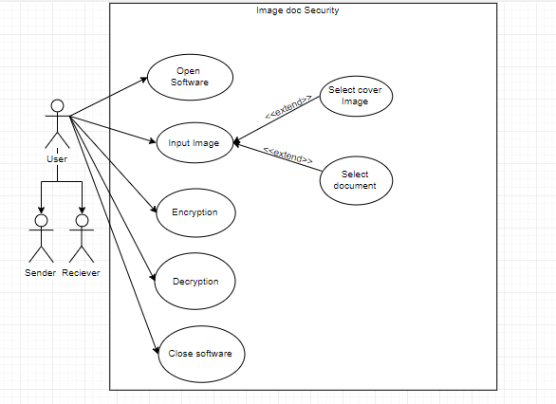

STEGPIXEL

**Figure 2:** Use Case Diagram

**4.2 Class diagram**

A class diagram is a picture for describing generic descriptions of possible systems.Class diagrams and collaboration diagrams are alternate representations of object models.Class diagrams contain classes and object diagrams contain objects, but it is possible to mix classes and objects when dealing with various kinds of metadata, so the separation is not rigid.

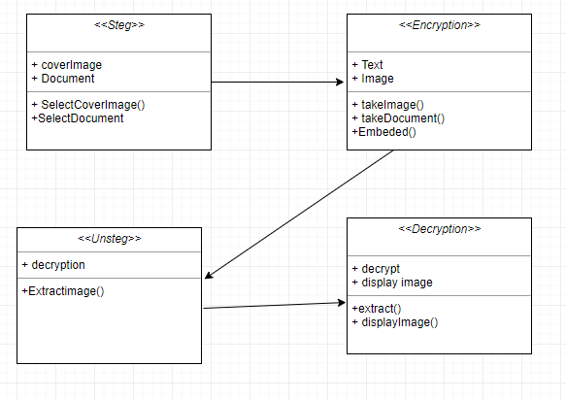

**Figure 3 :** Class Diagram

**4.3 Sequence Diagram**

A sequence diagram shows object interactions arranged in time sequence. It depicts the objects and classes involved in the scenario and the sequence of messages exchanged between the objects needed to carry out the functionality of the scenario.

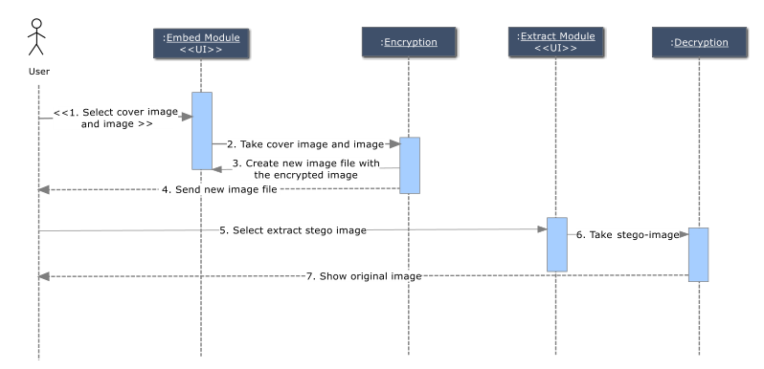

**Figure 4:** Sequence Diagram

**4.4 Activity Diagram**

Activity diagrams are graphical representations of workflows of stepwise activities and actions with support for choice, iteration and concurrency. In the Unified Modelling Language, activity diagrams can be used to describe the business and operational step-by-step workflows of components in a system. An activity diagram shows the overall flow of processes.

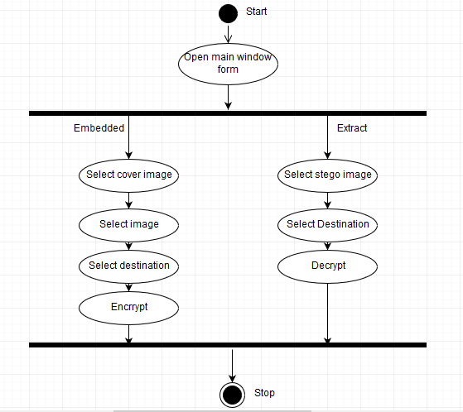

**Figure 5:** Activity Diagram

**4.5 Data Flow Diagram**

A data flow diagram (DFD) is a graphical representation of the "flow" of data through an information system, modelling its process aspects. Often, they are a preliminary step used to create an overview of the system which can later be elaborated. DFDs can also be used for the visualization of data processing (structured design). A DFD shows what kinds of information will be input to and output from the system, where the data will come from and go to, and where the data will be stored.

It does not show information about the timing of processes, or information about whether processes will operate in sequence or in parallel.

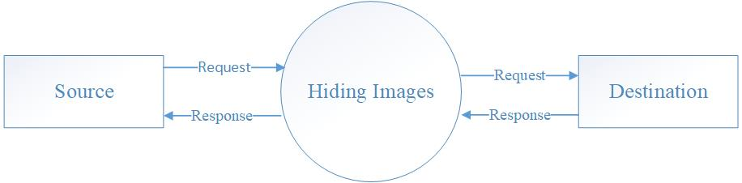

**Figure 6:** Context Diagram

1. **IMPLEMENTATION**

This is the first screen which has two tab options – one is Encrypt Image for encryption and another is Decrypt image for decryption. In right – top panel is displays the information about the image such as size, height and width.

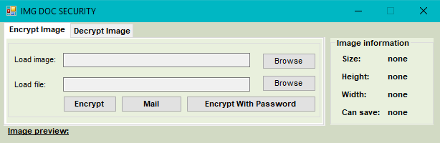

**Figure 7**: GUI

**5.1 Encryption**

For Encryption select Encrypt Image tab option.

For load image click on button “Browse” that is next to the Load Image text box.



**Figure 8**: Encryption tab

**5.1.2 Selecting cover file**

For load image click on button “Browse” that is next to the Load Image textbox. The file open dialog box will display as follows, select the Image file, which you want to use hide information and click on Open button.

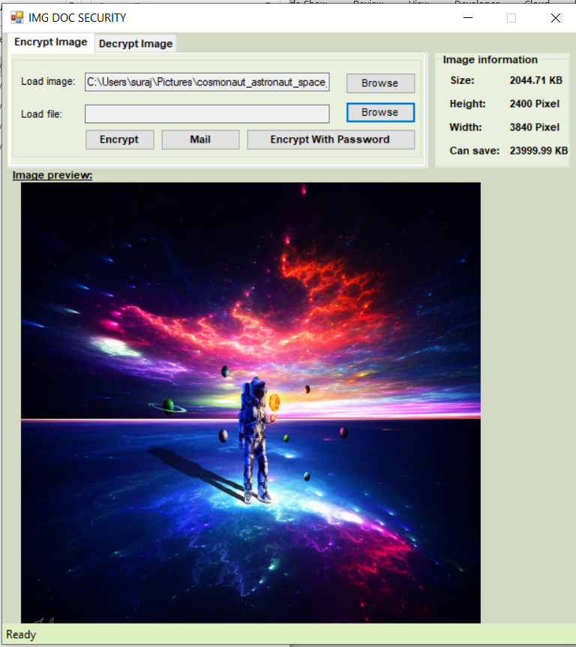

**Figure 9:** Selecting cover file

**5.2 Decryption**

Select the Decryption Image tab option.

Next click on the “Browse” button, which open the Open file dialog box.

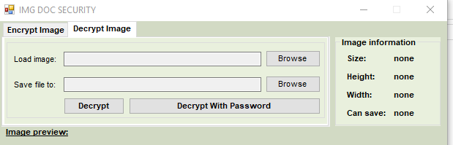

**Figure 10**: Decrypt tab

**5.2.2 Selecting output encrypting file**

Next click on the “Browse” button, which open the Open file dialog box, here you have to select the image which is Encrypted and has hidden information file. Select the image file and click on Open button.



**Figure 10:** Selecting output encryption

**5.3 Encrypt with password**

Click on “Encrypt” tab then click on “Encrypt with password” and Browse stego-image or any document then select “Encrypt” and enter password and click on “Start”. And select destination folder for Saving Encrypted File.

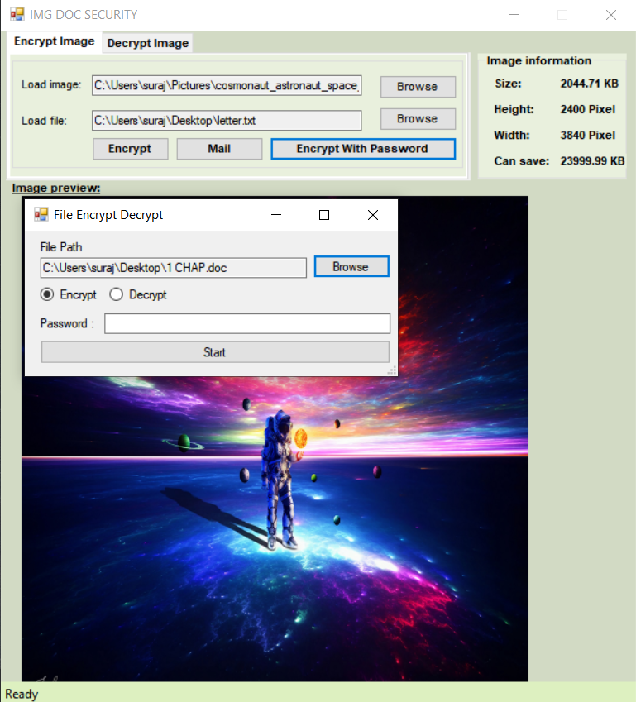

**Figure 11 :** Encryption with password

If you try to open that encrypted file you get the message which is shown in the image.

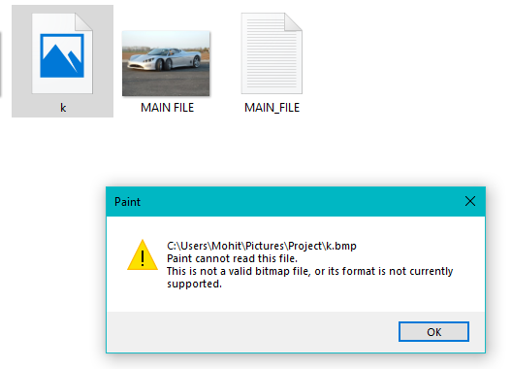

**Figure 12 :** Encryption with password

**5.4 Decryption with password**

Select Decryption tab then click on Decrypt with password. Browse stego-image or any document then select “Decrypt” and enter password and click on “Start”. And select destination folder for Saving Encrypted password.

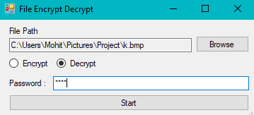

**Figure 13 :** Decryption with password

**5.5 Mail Sender**

Select “Encrypt Image” tab then click on “Mail” and provide all details and then click on send.

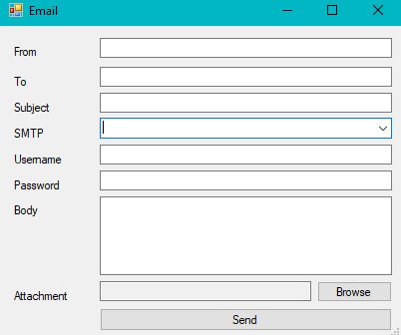

**Figure 14 :** Mail Sender

1. **LIMITATIONS & FUTURE ENHANCEMENT**

* **STEGPIXEL** is a window base application.
* This system is only for computers, not for mobile phones.
* In future we can implement this system for mobile phone(Android/IOS).

1. **REFERENCES & BIBLIOGRAPHY**

* **References**
* The Human Auditory System

<https://w3.ual.es/~vruiz/Docencia/Apuntes/Perception/Sistema_Auditivo/index.h> tml

* What is Human Visual System (HVS) | IGI Global

https://www.igi-global.com/dictionary/human-visual-system-hvs/13407

* Compute peak signal-to-noise ratio (PSNR) between images - Simulink

http://in.mathworks.com/help/vision/ref/psnr.html

* Central processing unit - Wikipedia

https://en.wikipedia.org/wiki/Central_processing _unit

* decibel | Definition, Formula, & Facts | Britannica.com

https://www.britannica.com/science/decibel

* **Bibligraphy**

Swain G and Lenka S K, “A Hybrid Approach to Steganography Embedding at Darkest and Brightest Pixels,” International Conference on Communication and Computational Intelligence, 2010.